**Exp No: 1 Analyze the problem and come with the entities in it. Identify what data has to be**

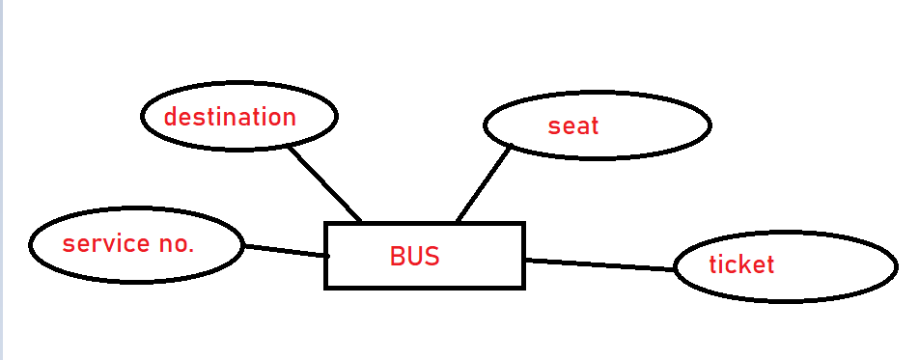**persisted in the databases. (E-R Model)**